Article 1

“Dynamic Methods for Building Knowledge Graphs: Task-Aware Graph Construction with LLMs”

1. Motivation
Recent work such as Paulheim et al., 2024 distinguishes task/application based evaluation—assessing a knowledge graph (KG) by its performance on a downstream task. Frameworks like KGBench, GEval, and KGrEaT (Heist et al., 2023) formalize such evaluations, providing standardized metrics for classification, regression, and recommendation tasks.
However, current KG construction frameworks—for instance methods exposed by LlamaIndex and LangChain—treat KG creation as a static process. They rarely incorporate downstream task feedback into extraction or ontology design. This disconnect leads to redundant computation that preserve irrelevant data (in case of automatic-ontology building)
The objective of this paper is to explore task-aware KG creation, seeking an optimal trade-off between complexity, and downstream utility. Specifically, we investigate methods that adapt KG generation to maximize performance on target tasks such as question answering and node classification.
As [Heist et al., 2023] observe:
“Performance indicators may be used to make an informed decision when picking a KG for a given task… and to compare different versions of a KG during its life cycle.”
In this work, we operationalize that principle—integrating downstream supervision into the KG creation pipeline itself.

2. Compared Methods
We evaluate one downstream setting — node classification/regression —and compare existing and proposed task-aware KG-construction strategies.

2.1 Task-Aware KG Construction
- Default approaches rely heavily on expert knowledge and manual ontology engineering or agent freely creating schema. (Langchain, llamaindex, neo4j)
- Zhang et al., 2025: automatic KG construction guided by clustering metrics; task-agnostic.
- Li et al., 2025: reinforcement-learning framework where downstream performance improvements serve as the reward signal.
- Kovács et al., 2023: KG creation guided by competency questions formulated by users.
- Gap identified: no work yet explores lightweight node-level predictor whose accuracy directly steers KG evolution. We propose such a feedback loop—periodically retraining a classifier on node embeddings and comparing results across candidate graph versions (+ using competency questions to arrive at optimal schema).
Illustration of feedback-based KG construction method on sample documents.
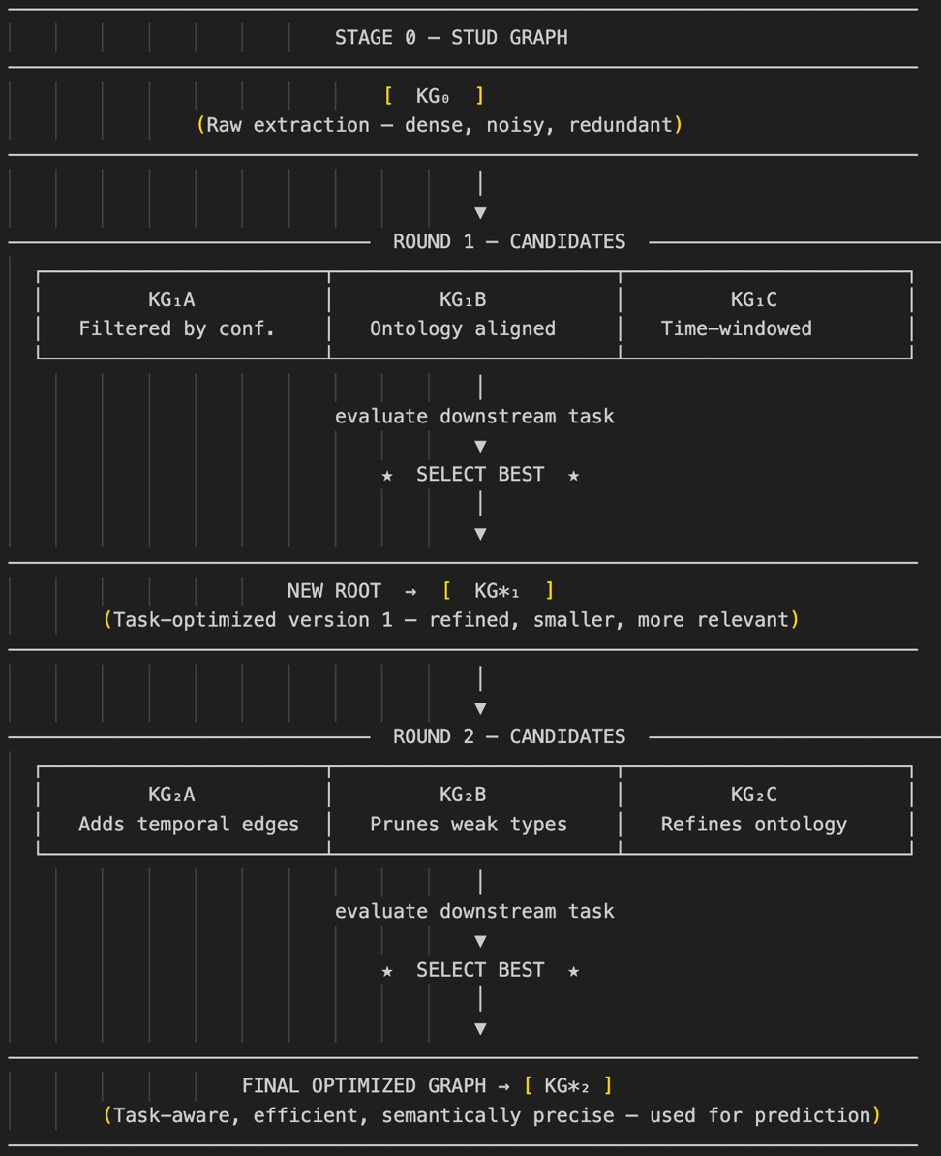
Resulting ontology is applied to build graph on entire document dataset.

3. Comparative Design and Dataset
We evaluate three KG-generation strategies on the same corpus:
- Baseline: unrestricted extraction using a generic framework (e.g., LangChain or Neo4J).
- Ontology-restricted: extraction constrained by a manually defined domain schema.
- Proposed task-aware method: adaptive KG construction where downstream classifier performance provides feedback to refine relation filtering and ontology weighting.

Dataset
We use the FNSPID dataset (ACM DL, 2024), which pairs financial news articles with subsequent-day (or hour, or 12-hour ….) stock-price movements for thousands of firms.
Documents supply textual input for KG extraction; prices supply supervised labels for the downstream task—predicting either price-direction or return magnitude. [Are bigger graphs better, can you create a sensible alogorithmic strategy basing on that???] We could also use some dataset & problem mentioned in KGBench or other evaluation frameworks.
This setup offers:
- Large-scale, document-based KG generation.
- Clear, quantitative prediction targets.
- Measurable feedback between graph quality and predictive accuracy.

4. Expected Outcomes and Validation
We expect that task-aware KG construction will:
- Improve prediction accuracy for node-level price-movement classification.
- Reduce graph size while maintaining or enhancing downstream performance.
- Identify which ontology relations contribute most to predictive utility.
- Generate graphs which are structurally informative
Evaluation metrics
- Predictive: AUROC, F1, Information Coefficient.
- Efficiency: Size, Runtime?
- Accuracy of answers
Validation will compare all four KG variants under identical downstream models (e.g., logistic regression or GNN)

5. Contribution and Significance
This study introduces dynamic, task-aware KG creation—closing the loop between KG construction and downstream performance.
Contributions
- A feedback mechanism linking classifier loss to KG-extraction parameters and ontology selection.
- An empirical demonstration on the FNSPID corpus showing that partial, task-optimized KGs outperform exhaustive extractions for prediction tasks.
- A blueprint for integrating such adaptive pipelines into LLM-based frameworks like LangChain and LlamaIndex.

6. Core Literature
- Paulheim et al., Structural Quality Metrics to Evaluate Knowledge Graph Quality, SWJ (2024). https://www.semantic-web-journal.net/system/files/swj3366.pdf
- A Comprehensive survey on automatic KG construction: https://dl.acm.org/doi/full/10.1145/3618295?casa_token=2TjT0yS19HwAAAAA%3Al77Cu9jHBUHaLTvGyPb6KyeFrJvtyV48t49DcI3xOjiWvo3zca2urZBSsUj93urMUE6s7A8D08Lo
- Heist et al., KGrEaT: A Framework to Evaluate Knowledge Graphs via Downstream Tasks, arXiv (2023). (https://arxiv.org/abs/2308.10537)
- Choi & Jung, GEval Framework Overview, PMC (2020). https://pmc.ncbi.nlm.nih.gov/articles/PMC7250612/#:~:text=GEval%20is%20a%20software%20framework,IRI)%20and%20the%20related%20vector.
- KGBench (https://kgbench.info).
- KG extractor with clustering approach: https://arxiv.org/html/2502.09956v1
- Kovács et al., Competency-Question-Driven KG Construction, CEUR (2023). https://ceur-ws.org/Vol-3471/paper4.pdf
- AKSW Group, LLM-KG-Bench, GitHub (2024). https://github.com/AKSW/LLM-KG-Bench
- Towards Automatic KG constructon from tabular data https://arxiv.org/html/2501.15282v1
- Test Driven KG creation – competency questions (https://ceur-ws.org/Vol-3471/paper4.pdf)
- KGGen: A Method for Extracting Knowledge Graphs from Plain Text Using Language Models https://arxiv.org/html/2502.09956v1
- AutoGraph-R1: End-to-End Reinforcement Learning for Knowledge Graph Construction https://arxiv.org/abs/2510.15339
- Buehler et al., Agentic Construction of Financial KGs, arXiv (2025). https://arxiv.org/pdf/2508.17906
- FNSPID Dataset, Financial News and Stock Price Integration Dataset, ACM (2024). https://dl.acm.org/doi/10.1145/3637528.3671629

Article 2
“Domain-Specific Applications of Task-Aware Knowledge Graphs: Stock Price Prediciton in Finance & Adverse Drug Response Report Severity Classification”

1. Motivation
While the generic method of task-aware KG construction (as in Article 1) defines the pipeline, its real value is demonstrated in document-rich domains where relational reasoning matter.
In finance it could be used for stock-price prediction (task from first aritcle), or fraud detection. In pharma KGs can be used to classify adverse drug reactions ADR reports (pharmacovigilance task), but also in linking active substances with diseases.
By applying a feedback-driven KG-creation loop—from documents to KG to downstream task—we aim to show that target KGs built from text can outperform general extractions.

2. Domains, Tasks & Methods
We evaluate the following settings:

2.1 Financial case – Subsequent-dat stock-price movements from News
- We use the FNSPID dataset (ACM DL, 2024), which pairs financial news articles with subsequent-day stock-price movements for thousands of firms

2.2 Healthcare A – Pharmacovigilance: Adverse Drug Reaction (ADR) Classification from Text-Linked Knowledge Graphs
- Corpus: BioDEX — Large Scale Biomedical Adverse Drug Event Extraction for Real-World Pharmacovigilance (D’Oosterlinck et al., 2023). The dataset contains ≈ 65 k PubMed abstracts and ≈ 19 k full-text biomedical papers annotated with 256 k document-level safety reports describing drug–ADR relationships.
- Downstream Task: Given a biomedical abstract or report and its linked drug node(s), classify whether the text provides evidence of a serious adverse drug reaction (1 = serious ADR, 0 = non-serious / none). The classifier utilisescontextual graph features derived from the ADR-KG.
- KG Construction Variants: Three/Four (with competency questions) variants as in Article 1
- Evaluation Metrics: AUROC, F1, AUPR, runtime / accuracy trade-off; qualitative analysis of extracted relations, ontology relevance.
- Supporting Literature:
  - D’Oosterlinck et al., BioDEX: Large-Scale Biomedical Adverse Drug Event
Extraction for Real-World Pharmacovigilance, https://github.com/KarelDO/BioDEX?tab=readme-ov-file
  - Kuhn et al., SIDER: Side Effect Resource 5.0, Nucleic Acids Research, 2023. https://academic.oup.com/nar/article/44/D1/D1075/2502602
  - Lee et al., BioBERT: A Pre-Trained Biomedical Language Representation Model, Bioinformatics, 2020. https://academic.oup.com/bioinformatics/article/36/4/1234/5566506
  - Prediction of adverse drug reactions based on KG embedding https://bmcmedinformdecismak.biomedcentral.com/articles/10.1186/s12911-021-01402-3

3. Comparative Design & Evaluation
For each domain we run the four KG variants: build KG_i, compute embeddings, train downstream predictor/link-prediction model, evaluate performance & cost, then select best KG as new root and optionally iterate.
Graph topology statistics (avg degree, clustering) can also be compared across variants and domains.

4. Expected Outcomes
We expect the task-aware variant to:
- Improve downstream performance
- Reduce graph size/triples by ~30–50 % relative to baseline, while matching or surpassing performance.
- Reveal domain-specific relation-types critical for performance
- As compared to baseline

5. Contribution & Significance
This article
- Demonstrates cross-domain applicability of task-aware KG construction using documented text corpora,
- Provides further quantitative evidence that adaptability of KG (via downstream feedback) yields performance-cost gains,
- Identifies relation/ontology importance per domain,

Kwestie różne :
1. Technicznie mogę zebrać klucze API z kilku kont openai lub zawnioskować i deployment na Azure. W celu entity recognition skorzystać z gotowych pakietów.
2. Finansowy use-case mogę przenieść do części aplikacyjnej natomiast w pierwszej pomyśleć o syntetyzacji jakichś danych…
3 Czy jest tekstowy zbiór benchmarkowy??

Mógłbym zobaczyć ten RL

--------------------
- We have the generation of data which could be unbiased for example… (CausalVAE etc.) and increasing metrics on downstream tasks. It could also help personalise medicine. It is a method of creating digital twins when some underlying causality is suspected.
- We have knowledge graphs and with causal and temporal edges which could encode sets of rules so that they will enable LLMs for reasoning. (graph rag which could retrieve numerous structures not just similar things).

It can generate some data given the true dag not estimate it but be given the true dag and thus create certain datasets which reinforce certain relationships (learning just coefficients).
And also it can be used for labelled with features examples and samples (for example we differentiate 2 kinds of text as we want to be able to disentangle this feature)
First article literature:
- FNSPID (https://dl.acm.org/doi/10.1145/3637528.3671629)
- Task-Aware Graph Consttruction on Features (https://www.vldb.org/2025/Workshops/VLDB-Workshops-2025/TaDA/TaDA25_5.pdf)
- Structural Characteristics of Knowledge Graphs Determine the Quality of Knowledge Graph Embeddings Across Model and Hyperparameter Choices (https://ceur-ws.org/Vol-3573/paper2.pdf)
- An Ontology-enhanced Knowledge Graph Embedding Method (https://dl.acm.org/doi/fullHtml/10.1145/3633637.3633645 )
- From human experts to machines (https://arxiv.org/html/2403.08345v1 )

Implementation development ideas:
Hope embeddings, small sample, LLM embedinngs from text entities, Kierunkowa modyfikacja agentowa, z małymi krokami. Pytania do kroku ewaluacyjnego

Benchamarki jakości - Llamaindex Graph Construction (free and expert driven), Test driven KG construction (competency questions)

I think that I would like to have a framework utilising structured outputs which will not use Neo4J and do something a bit different: 1. First build the graph with metadata nodes required for task (days, articles, chunks) 2. Then focus on ontology driven entity and relationships extraction where we are not duplicating what is already done 3. Thus one step of entity extraction should feature such parts: A. get given chunk B. have context which step it is and what it will be doing C1. if it is extracting new entities and relationships from chunk it needs to simply do it on a chunk of text and add it to graph under correct chunk node C2. If it is building on top of exisiting entiteies extracted from chunk (say there is a person and now we are trying to understand what is their occupation) it will read the chunk again and then connect the newly extracted entities and realtionships to existing ones After certain stage where entire sample text is read of course I need to perform some entitiy resolution so that names of relationships and entities will be standardised

Scaling idea

Wniosek o klaster na ICM instancje modeli embeddujących i SLM-a wyciągającego entity.

New embedding pipeline idea (KG textualization)
Article ID
↓
Get Mentioned Entities [E1, E2, E3, ...]
↓
Filter by Candidate Rels
↓
Extract ALL Chains from entity pairs
↓
SORT by hops (descending)
↓
KEEP TOP 10 ← NEW CONSTRAINT
↓
Convert to Text: max 10 chains
↓
Embed: max 10 embeddings (1536 dims each)
↓
Aggregate: chain_agg_emb (1536 dims)

Graph progression cypher queries

MATCH (n)-[r]-(m)
WHERE 'base_structure' IN coalesce(r.candidate_tags, [])
RETURN n, r, m

MATCH (n)-[r]-(m)
WHERE 'step_1_candidate_0' IN coalesce(r.candidate_tags, [])
RETURN n, r, m

MATCH (n)-[r]-(m)
WHERE 'step_2_candidate_1' IN coalesce(r.candidate_tags, [])
RETURN n, r, m

MATCH (n)-[r]-(m)
WHERE 'step_3_candidate_0' IN coalesce(r.candidate_tags, [])
RETURN n, r, m

Obszar | ZA | PRZECIW
Wynagrodzenie | 55k$ rocznie + darmowe mieszkanie dla deweloperów | Zarabiam więcej przy znacznie mniejszym zaangażowaniu czasowym + utrata opcji kredytu na mieszkanie
Equity | 2% udziałów to dużo jak na founding engineer, potencjalnie ~1% po dilution | Pre-seed oznacza duże ryzyko, że equity będzie warte 0. Brak kontroli nad spółką
Doświadczenie | Intensywne budowanie end-to-end, szybki rozwój w technologiach webowych/agentowych; lifestyle | Mogę spędzić rok na chaosie zamiast na „solid career capital” I uczeniu się czegoś głębszego niż manipulacja APIs  Mógłbym spróbować dostać się na stypendium i mieć doświadczenie zagraniczne w ramach doktoratu.
Rola / status | “Founding engineer” jest okej w CV, ciekawe środowisko | Nie jestem cofounderem → dużo odpowiedzialności, mało władzy; Tutaj też mam ciekawe środowisko, z którym przerywam kontakt
Produkt / rynek | „AI Agenci w grach i na discordzie, których trudno odróżnić od człowieka”  Gaming + moderacja to realny problem i potencjalnie duży rynek; pomysł jest mniej istotny od kapitału i egzekucji | Pomysł jest generyczny i niedookreślony, brzmi hype’owo, brak jasnej monetyzacji. Dlaczego na tym etapie zatrudniają już 3 inżynierów?
Runway / stabilność | Pre-seed z inwestorem → sygnał wiarygodności | $350k inwestycji starczy na 6-9 miesięcy
PhD | Mogę „zamrozić” doktorat i wrócić z mocnym doświadczeniem | Ryzyko przerwania trajektorii — z doktoratu też może narodzić się pomysł biznesowy
Bayer | Więcej poczucia wpływu i adrenaliny | Bayer daje pole do wdróżenia pomysłu z doktoratu a etat możliwość wzięcia kredytu
Społeczność | Barcelona + ekspozycja na społeczność startupową; lifestyle | Tracę ekspozycje tutaj (konferencje, artykuły, firma, możliwy własny projekt)
Psychologia | Realizacja marzenia „budowania” może być spełniająca w gronie podobnych zapaleńców | Duży wysiłek dla marzenia kolegów
Efekt | Ciekawe Doświadczenie, Wpis do CV, Niezerowa Szansa Sukcesu | Jeśli startup padnie, zostaje z przerwanym doktoratem, skokiem w CV i zmęczeniem

